5. SYSTEM EVALUATION

-The PDCA Cycle- PDCA (plan–do–check–act or plan–do–check–adjust) is an iterative four-step management method used in business/teams for the control and continuous improvement of processes and products.

This is one of the techniques we have implemented in our project. Now I will explain what each section contains in depth.

**PLAN**

Establish the objectives and processes necessary to deliver results in accordance with the expected output (the target or goals). By establishing output expectations, the completeness and accuracy of the [spec](https://en.wikipedia.org/wiki/Specification_(technical_standard)) is also a part of the targeted improvement. When possible start on a small scale to test possible effects.

**DO**

Implement the plan, execute the process and make the product. Collect data for charting and analysis in the following "CHECK" and "ACT" steps.

**CHECK**

Study the actual results (measured and collected in "DO" above) and compare against the expected results (targets or goals from the "PLAN") to ascertain any differences. Look for deviation in implementation from the plan and also look for the appropriateness and completeness of the plan to enable the execution, i.e., "Do". Charting data can make this much easier to see trends over several PDCA cycles and in order to convert the collected data into information. Information is what you need for the next step "ACT".

**ACT**

If the CHECK shows that the PLAN that was implemented in DO is an improvement to the prior standard (baseline), then that becomes the new standard (baseline) for how the organization should ACT going forward (new standards are enacted). If the CHECK shows that the PLAN that was implemented in DO is not an improvement, then the existing standard (baseline) will remain in place. In either case, if the CHECK showed something different than expected (whether better or worse), then there is some more learning to be done... and that will suggest potential future PDCA cycles. Note that some who teach PDCA assert that the ACT involves making adjustments or corrective actions... but generally it would be counter to PDCA thinking to propose and decide upon alternative changes without using a proper PLAN phase, or to make them the new standard (baseline) without going through DO and CHECK steps.

5.1 TESTING AND ROBUSTNESS

---- Extending on the methodology ----

5.2 PERFORMANCE BENCHMARKS

*“Benchmarking is the systematic process of measuring one’s performance against recognized leaders for the purpose of determining best practices that lead to superior performance when adapted and utilized.”*

These are the steps I used to organize my Performance Benchmarking:

* Determine what to benchmark,
* Define the measures and add fixes

5.2.1 DETERMINE WHAT TO BENCHMAERK

What we are benchmarking is the performance of our application that was created in Unity. The method that we approached was placing our application on the android phone. This showed that our application was running. This process allowed us to see where the project was having loading problems.

When approaching the section that connected to the database there was a long loading time, where the application was checking if new input was added to the database. The rest of the application had great loading time.

5.2.2 DEFINE THE MEASURES AND ADD FIXES

To define the time that the application was taking to run when connecting to the database we ran the application on the phone. The loading time was about 20 seconds. It took the application 20 seconds to connect to the database add all the new input and play the game chosen.

After researching how to fix this problem, Diarmuid decided to add a timer. The timer basically added a time limit on the loading time of the section. A 10 second limit was set, if the application didn’t pull the data added in these 10 seconds the application starts the game without pulling the new assets added.

5.3 COMPARING – OUTCOMES AGAINST OBLECTIVES

This section will hold the process of comparing the outcomes against the objectives we have set in the beginning. Every section of the application will undergo this procedure individually. This is in order to explain fully what each part was actually meant to do and what it came out in the end doing. The purpose of this section is to see all the solutions that were tried, all the work that went into doing each section and the end product. There were only three sections where games were added, therefore only these three sections will be explained in this section.

5.3.1 CREATE AND PLAY

5.3.2 LEARN IRISH

5.3.3 OCEAN FACTS

**What this section was describes as in the specification:**

The Ocean Facts section draws from the theme of sailing with Captain Cillian. It contains multiple scenes (Currently just an aquarium scene) which can be navigated through like a slideshow. The scenes contains pictures of relevant animals and facts about each.

**Objectives from the Introduction overall to be implemented:**

* More quality and less quantity.
* Cross platform.
* Overall publishing client’s books.

**Objectives specifically for this section:**

* Having one working puzzle called Pick and place with different facts.
* Making this section fun as well as adding facts.

**Process of getting the final outcome:**

1. *Created a template page in unity with facts and images of sea creatures*- The page looked somewhat like the picture below. To make sure I was going for what the client wanted, I set up a meeting and displayed this template to her. She was not very happy with just having information with a few images. This is because she was imagining the application to be used in a classroom. Therefore she asked for a word search, or a hand man that the children could play in classes.

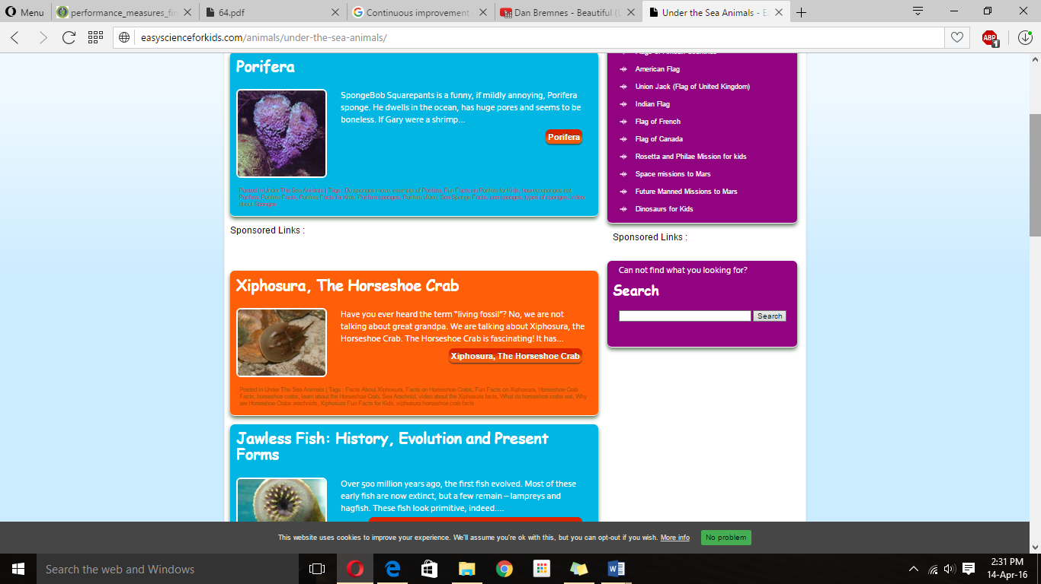

1. *Made a word search:* - after the meeting, I decided to make a word search and try to implement this to fit the application. But by making a word search there was no way I could add the facts she wanted to display. Therefore I had to go and research on more children’s applications and games, where I could also implement some facts.

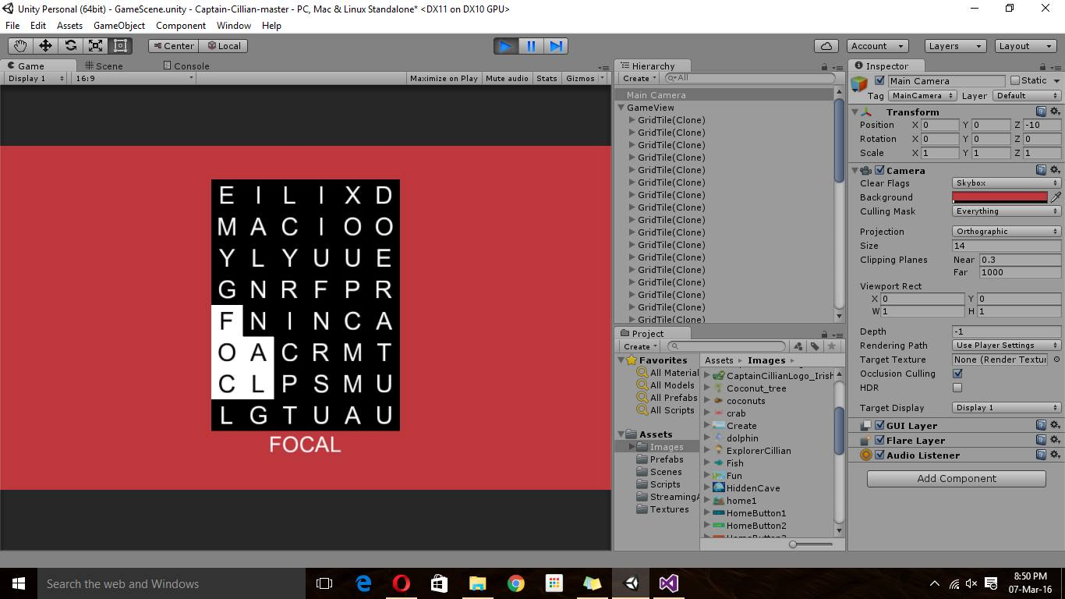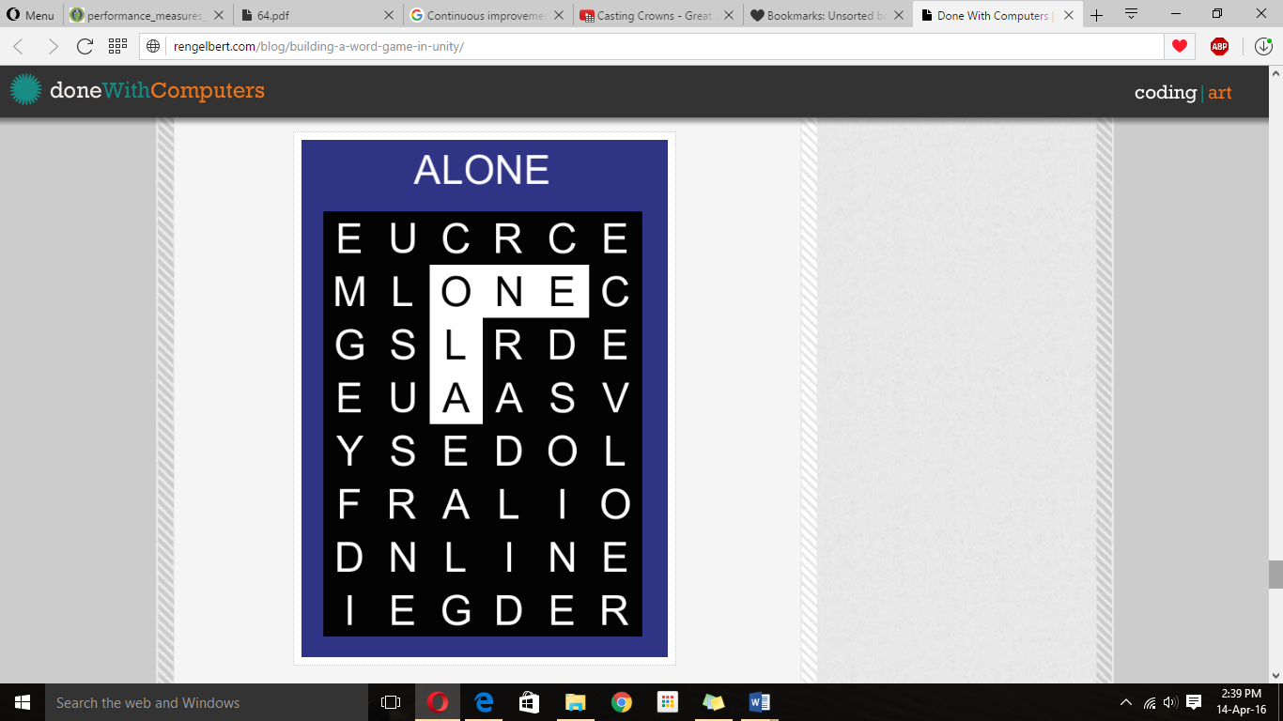

1. *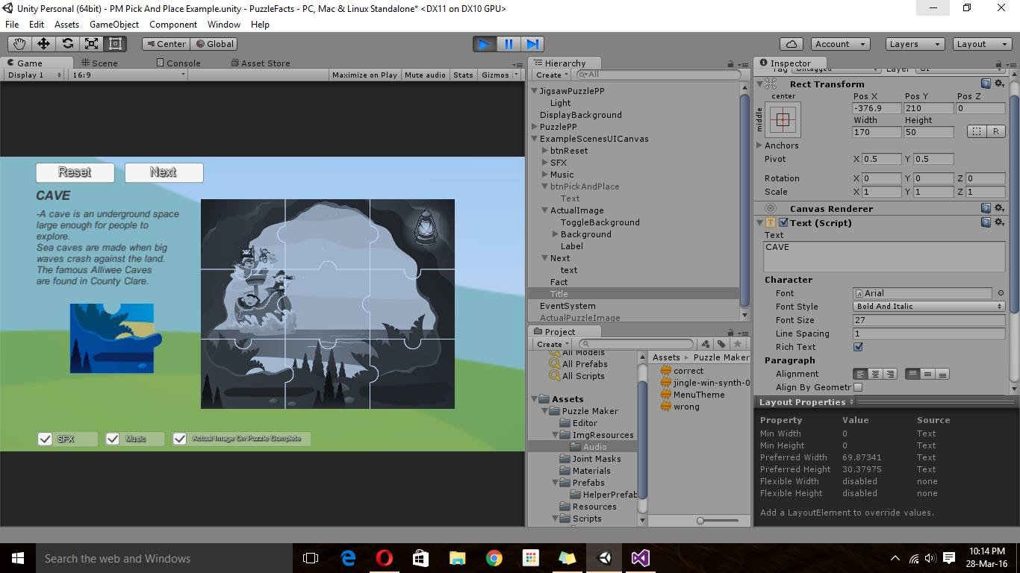Puzzle Idea –* after doing a few more days of research I found a great unity asset store package. This package contained a puzzle game. This brought me to the idea of creating one puzzle game and adding facts to it that the user can show and hide to their preference. This was a great idea and considering the time I had left to finish this project it was the idea I decided to implement in the end.

**Outcomes –**

* Choosing to do this puzzle was the best Idea in my case.
* It shows educational facts
* It’s fun and appropriate for children to play in classrooms as well as at home.
* Level of complexity is appropriate for the group of children we are targeting.
* Its cross platform
* It has a really good quality because I used the unity assets package, so the game was basically done when I got it, it had sound and the movements were perfectly functioning. Therefore meeting the client’s objectives.
* Took a lot of trial and error but in the end it was worth all the research and time spent on it.

5.4 LIMITATIONS AND OPPORTUNITIES

5.4.1 LIMITATIONS

* **Time frame limitation:** we were limited to the time we had to spend on the project. The first few weeks for us were more of getting the team members on bored with the project since it was ongoing from last year. A lot of research was done to see what the client didn’t like about the last project and what we had to change. In our case we had to start the project again since we decided to use unity and to make the project cross platform. Some of the team members were not used to using Unity so that took extra work and extra time spent to understand how the software worked. Also the deadline 18th April.
* **Software Limitations:** since we had to do a cross platform application we were limited to what software we could choose. There is only a few amount of software that actually allow cross platform. We had a choice between Unity, Ionic and PhoneGap.

5.4.2 OPPORTUNITIES

* **Hardware/software evolution:** we had the opportunity of working with new software that is in demand. These new software allowed us to create a more quality application, also a wonderful war to test this code by adding it to the phone and not changing the code. The new online databases are very useful for projects created at the minute. Fee for a year it gives the clients you develop for an opportunity to try something new they perhaps never considered before.
* **Using code that is already there and making it better:** For example unity asset store , this gives opportunity to use code that is already made and that are very well made that are high in quality giving your application a polished look. Also GitHub had a lot of code samples you could take and change to suit your project.